IM3000 Timer

Features

- Eight 5-bit timer/counter channels
- Each channel may cover time interval from 12 ns up to 49 μS and two or more channels may be chained together to achieve longer period
- Interrupt signal for each channel
- Functions including:
  - Delay timing
  - Pulse generation and Pulse width modulation (PWM)
  - Interval or frequency measurement
  - Configurable output polarity
  - Event counting

Timer Channel Description

A timer channel consists of a 5-bit down counter and some configurable registers as shown in Figure 1.

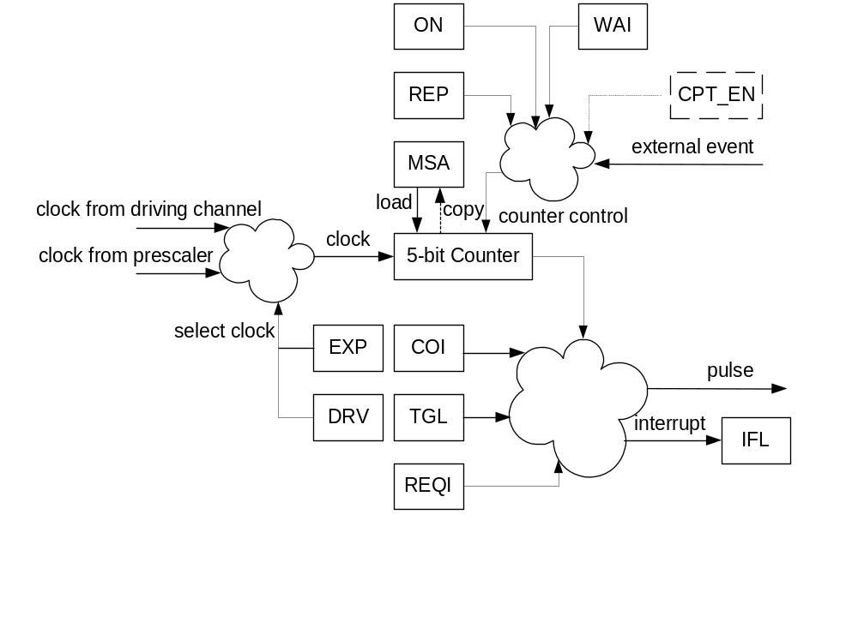
Figure 1. A channel block diagram

Timer Configuration

Timer configurable registers are accessed via internal port M, where the port data register contains data to configuration registers, and the port control register contains address to the configuration registers. For example, to write EXP and MSA in channel 2 with “001” and “01111”, the microcode is:

DSOURCE CONSTANT 2F, LOAD DPORT M (set EXP=001 and MSA=01111)
DSOURCE CONSTANT 82, LOAD CPORT M (write to Ch2)

To read from the same register, the microcode is:

DSOURCE CONSTANT 02, LOAD CPORT M (read from Ch2)
Other cycle
DSOURCE DPORT M (get EXP and MSA)

Note the “other cycle” inserted above to allow data time to be available before reading it.
Configurable register address and bit map are defined in Table 1.

Table 1. Register address and bit map
Address | Bit map
Address | 7 | 6 | 5 |  | 4 | 3 | 2 | 1 | 0
W0000ccc | EXP |  |  |  | MSA
W0010ccc | REQI | TGL |  |  | COI
W0100ccc | REP | EVT | DRV |  | WAI |  |  | Not used
W0001000 | Not used | LCD |  | CPT_EN | Not used
10011000 | Reset channel ON register
10011000 | Ch7 | Ch6 | Ch5 |  | Ch4 | Ch3 | Ch2 | Ch1 | Ch0
10101000 | Set channel ON register
10101000 | Ch7 | Ch6 | Ch5 |  | Ch4 | Ch3 | Ch2 | Ch1 | Ch0
10111000 | Reset channel IFL register
10111000 | Ch7 | Ch6 | Ch5 |  | Ch4 | Ch3 | Ch2 | Ch1 | Ch0
00011000 | Read ON register
00111000 | Read IFL register

Notes:
1. W = 1 for write access; W = 0 for read access;
2. ccc = channel number in binary format.

Configurable Registers

The functions of configurable registers are described in Table 2.

Table 2. Configurable Register Functions

Register name | Access type | Bit width | Functions
EXP | R/W | 3 | Channel’s counter clock frequency is 83.3MHz/(2**EXP) if this channel is not driven by the adjacent channel with lower channel number.  If it is driven by a channel, the EXP field take on another meaning:  EXP(0): If set, and the driven timers REP bit is clear, the driving timer will turn off once both timers reach zero, even if its REP bit is set. Use this to create an extended one-shot counter.  EXP (1): If set, the driving channel will wrap around instead of reloading its MSA when it reaches zero, providing the driven channel is not also zero. Set this to create an extended timer, clear it to use the driven channel as a loop counter for the driving channel.  EXP (2): If set, coincidence in this channel will not be affected by coincidence in the driving channel.
MSA | R/W | 5 | Counter is loaded from MSA value at start, and when it counts to zero and its REP bit is set. When external event capture function is used, the counter value is copied to MSA when an event happens (Ch0 and Ch1 only).
REQI | R/W | 1 | Channel is interrupt enabled when REQI set to ‘1’ (See also IFL). Interrupt will be generated just when the timer wraps, or when it shuts off if it’s set up for one-shot operation.  The exception is channel 0; in the capture mode (CPT_EN set), interrupt from this channel is instead generated when a capture occurs.
TGL | R/W | 2 | Channel toggle output mode selection.  00: No toggle.  01: Set at start and reset at end. Can be used for single-shot pulse, even if the timer will repeat.  10: Set at counter = COI and reset at counter /= COI. Generates a one-cycle (timer cycle) pulse at a specified offset into the timer wrap period.  11: Set at counter = COI and reset at counter = 0. Can be used to generate a pulse with specified duty cycle.  In the case of chained counters, use the toggle output of the higher-numbered channel.
COI | R/W | 5 | Coincidence value, used for toggling output.
REP | R/W | 1 | Counter is reloaded with MSA value and repeated counting when it counts to zero if REP is set to ‘1’.
WAI | R/W | 1 | Counter is triggered to start counting by an external event if WAI is set to ‘1’.
DRV | R/W | 1 | Channel’s output pulse is driving the adjacent channel with higher channel number if DRV is set to ‘1’.
ON | R/W | 8 | Channel is active when ON is set to ‘1’. ON is reset by either processor or when channel counts to zero and REP = ‘0’.
IFL | R/W | 8 | Channel interrupt flag is set to ‘1’ when REQI = ‘1’ and it counts to zero (REP = ‘0’), or an external event is captured (only Ch0 and Ch1). Only processor can reset.
EVT | R/W | 1 | Channel 0 is clocked by external event if EVT is set to ’1’.
CPT_EN | R/W | 2 | External pulse capture enable (only for Ch0 and Ch1).
LCD | R/W | 1 | Configure channels for LCD driver usage.

I/O Signals

The polarity of each channels external trigger/capture signal or pulse output signal is configurable via data register in Port C (TBD), as shown in Figure 2. Timer internal logic is always triggered at positive edge of “trigger/capture” signals.

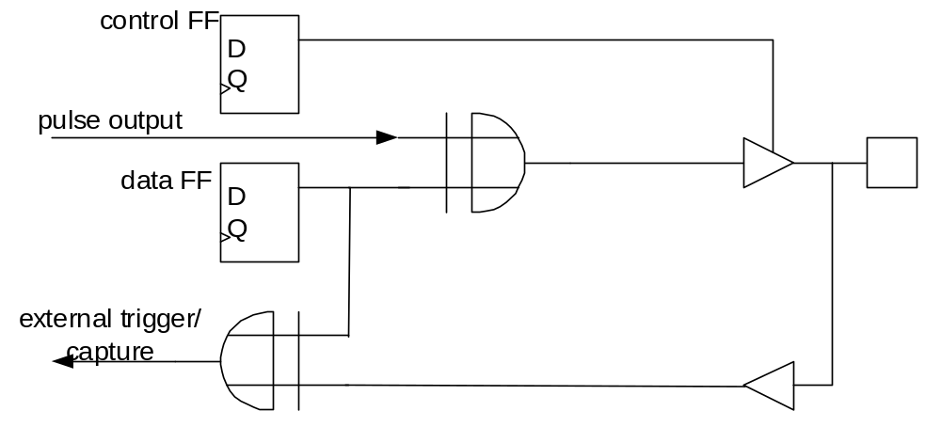

Figure 2. Control of Polarity of I/O Signals

Typical Applications

Some timer typical applications are illustrated here.

Delay Timing
In application programs where there is a predefined delay timing, then one or more timer channels may be used to enable CPU doing others tasks during the time, as shown in Figure 3.

Figure 3. Delay Timing

Pulse Generation and PWM

With 30 ns to 3.84 μS resolution, each timer channel provides a wide frequency range to generate desired duty cycle pulses, as shown in Figure 4.
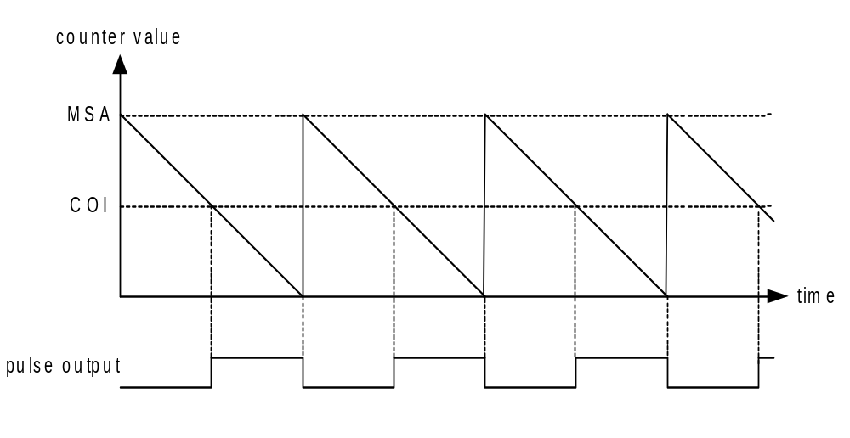
Figure 4. Pulse Generation and PWM

Interval Measurement

Timer Channel 0 and Channel 1 have a “capture” function when they are chained together, which can be used to measure an external time interval in form of a pulse, as shown in Figure 5. At the external pulse start edge Channel 0 and Channel 1 start counting. At the pulse end edge both channel’s MSA register is loaded with counter’s value. Processor may read these MSA registers upon interrupt request from timer and calculates the interval. The polarity of the start and end edges are invertible due to configurable of timer I/O signals.

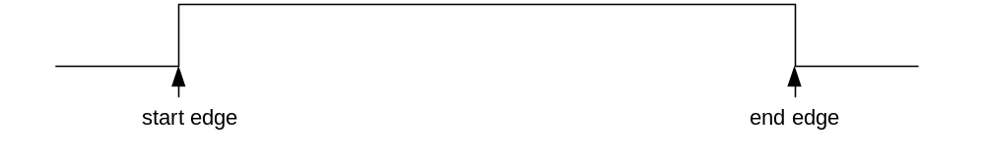
Figure 5. Interval Measurement

